This document will outline how to apply barcodes to SQL Reporting Services reports.

Barcodes are rendered as images within SSRS, so to be able to produce a barcode on a report, the value to be printed must be passed through an image generator and displayed on the report as an image.

To set this up on the SSRS running server, the following needs to be in setup and configured:

**Copy file "BarcodeLib.dll" to the following locations on the SSRS server:**

1. For Standalone version of SSRS:

*C:\Program Files\Microsoft SQL Server Reporting Services\SSRS\ReportServer\bin*

1. For full SQL version installation:

*C:\Program Files\Microsoft SQL Server\MSRS10_50.MSSQLSERVER\Reporting Services\ReportServer\bin*

1. For development / report builder:

*C:\Program Files (x86)\Microsoft Report Builder*

*C:\Program Files (x86)\Microsoft SQL Server\Report Builder 3.0*

**Inside each report the following changes are to be made:**

1. Report properties  
   1. Select Report Properties (right click off the report page)  
        
      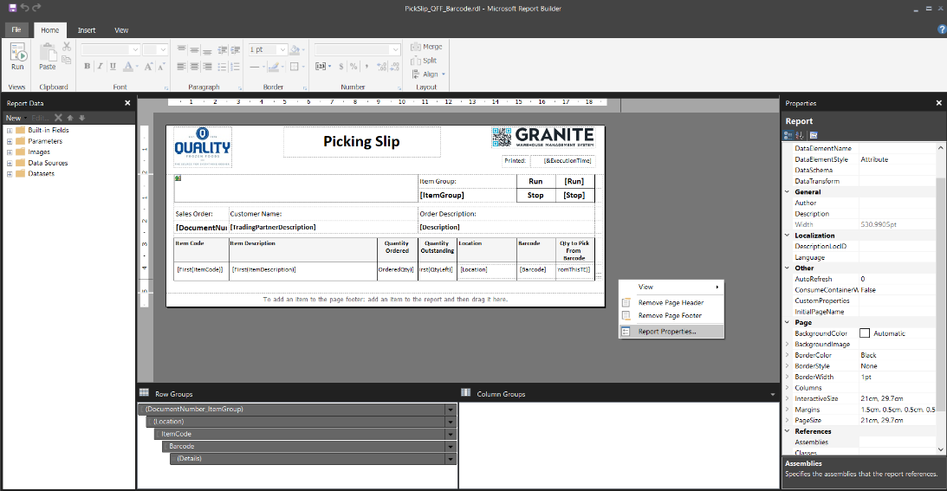
   2. The report properties require 2 changes:  
      1. Select menu option References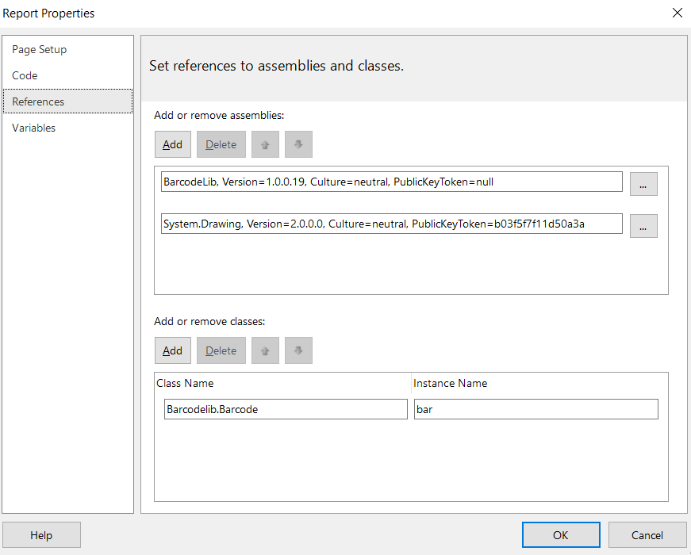  
         1. Add References to “BarcodeLib.dll” and “System.Drawing.dll” from the following:
      * BarcodeLib.dll (use server folder from above, i.e. standalone / full server)
      * System.Drawing.dll (C:\Windows\Microsoft.NET\Framework\v2.0.50727)  
        1. Add Classes
      * Class Name = Barcodelib.Barcode
      * Instance Name = bar
      1. Select menu option Code   
           
         This is localised report code which will pass through the value to barcodelib and generate an image   
           
         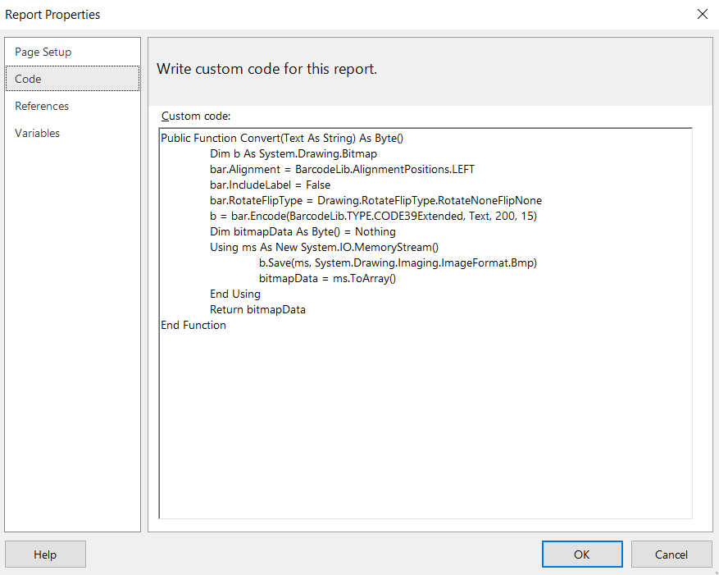  
           
         Insert the following code for Code 3of9 barcode

*Public Function Convert(Text As String) As Byte()*

*Dim b As System.Drawing.Bitmap*

*bar.Alignment = BarcodeLib.AlignmentPositions.LEFT*

*bar.IncludeLabel = False*

*bar.RotateFlipType = Drawing.RotateFlipType.RotateNoneFlipNone*

*b = bar.Encode(BarcodeLib.TYPE.CODE39Extended, Text, 200, 15)*

*Dim bitmapData As Byte() = Nothing*

*Using ms As New System.IO.MemoryStream()*

*b.Save(ms, System.Drawing.Imaging.ImageFormat.Bmp)*

*bitmapData = ms.ToArray()*

*End Using*

*Return bitmapData  
End Function*

Insert the following code for Code128 barcode

*Public Function Convert(Text As String) As Byte()*

*Dim b As System.Drawing.Bitmap*

*bar.Alignment = BarcodeLib.AlignmentPositions.LEFT*

*bar.IncludeLabel = False*

*bar.RotateFlipType = Drawing.RotateFlipType.RotateNoneFlipNone*

*b = bar.Encode(BarcodeLib.TYPE.CODE128, Text, 400, 50)*

*Dim bitmapData As Byte() = Nothing*

*Using ms As New System.IO.MemoryStream()*

*b.Save(ms, System.Drawing.Imaging.ImageFormat.Bmp)*

*bitmapData = ms.ToArray()*

*End Using*

*Return bitmapData*

*End Function*

1. Barcode in report  
   1. In report layout / design, insert an Image into the area for the barcode to be printed  
      1. For Code3of9 Barcode   
           
         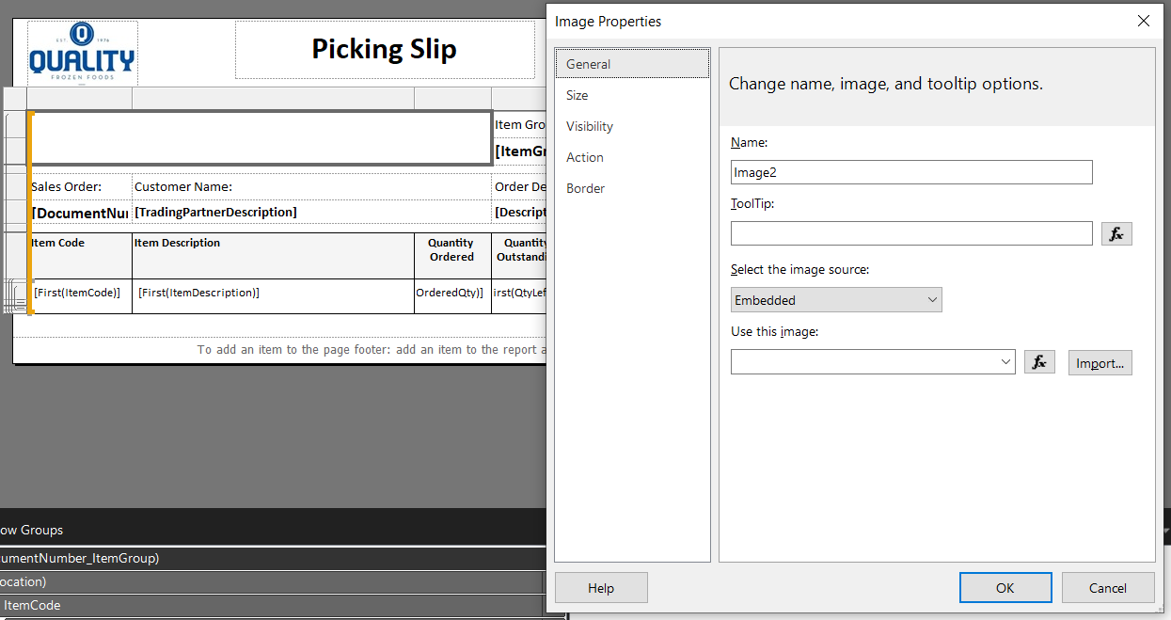  
           
         Settings to note for image added:  
         Image source Database  
         Expression =Code.Convert("*" & Fields!DocumentNumber.Value & "*")  
         MIME Type image/bmp  
         Size Fit Proportional
      2. For Code128 Barcode   
           
         Graphical user interface, application

         Description automatically generated  
           
         Settings to note for image added:  
         Image source Database  
         Expression =Code.Convert(Fields!DocumentNumber.Value)  
         MIME Type image/bmp  
         Size Fit Proportional